Project Planning Phase
Project Planning Template
Date | 2 September 2026
Student Name
Project Name | Employee Raise Issue
Maximum Marks

Product Backlog, Sprint Schedule and Estimation
Sprint | Functional Requirement (Epic) | User Story / Task | Story Points | Priority | Student Name
Sprint-1 | Foundation | Create scoped application, Employee Raise Issue table and fields. | 6 | High | Naga Prathyusha Gujjula
Sprint-2 | Rules | Configure UI Policies, dependencies and Record Producer. | 6 | High | Naga Prathyusha Gujjula
Sprint-3 | Portal | Create Requesting Portal and widgets. | 6 | High | Naga Prathyusha Gujjula
Sprint-4 | Validation | Testing and documentation. | 2 | High | Naga Prathyusha Gujjula
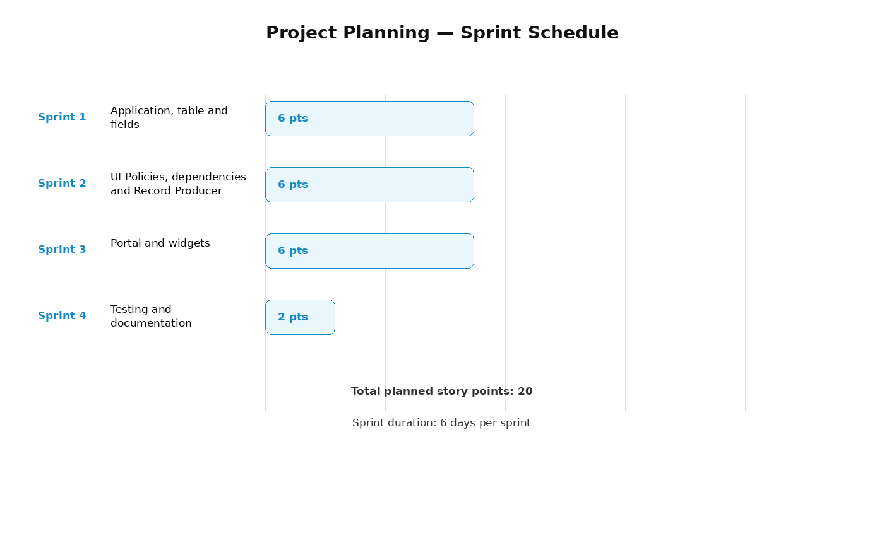
Figure 1: Sprint schedule and story-point representation.
Project Tracker
Work Item | Status | Validation
Scoped application | Completed | Employee Center created and selected.
Custom table | Completed | Employee Raise Issue table created.
Fields | Completed | Required fields configured.
UI Policies | Completed | Short Description mandatory for New; Number read-only.
Dependent choices | Completed | Category controls Subcategory.
Catalog item | Completed | Raise Employee Issue created with mapped variables.
Portal | Completed | Requesting Portal configured.
Custom widgets | Completed | Commercial and Link Redirect widgets created.
Testing | Completed | Portal navigation and issue submission validated.

